DVPF5, DVPFX1
Subject
Will not play video recorded on DVD-RW media.

SYMPTOMS
Can't Play DVD-R/w Discs.
CAUSE
The DVP-FX1 unit is not playing discs recorded on DVD+RW media. The unit will play video recorded on DVD-R media, but gives a no disc error when attempting playback using DVD+RW media. Recorded video on Pioneer DVD-RW disc using a Sony Viao PCRX490TV using bundled software Sonic DVDit version 2.3.
RESOLUTION
The optical pickup in the units itself has a capability to playback DVD-RW disc, but since the unit uses different method in detecting the disc, in most cases the unit can not detect the disc and results in No DISC errors. The reason the unit uses different a different detection method is for safety reasons. The unit uses the CD laser for detection in order to protect customer's eyes from the laser used for DVD.

DVPF5, DVPFX1, DVPNC600, DVPNS300, DVPNS400D, DVPNS700P
Subject
Information of P/N for SYSCON ROM

SYMPTOMS
SYSCON ROM listings for DVD Players
CAUSE
The following are the part numbers of the SYSCON ROM for each model.
RESOLUTION
See chart SYSCON ROM TABLE:
SUPPORTING DOCUMENTS AND GRAPHICS
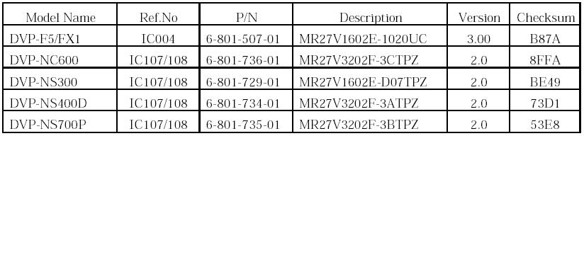

Model DVPF5: Features

*LCD SCREEN NO
*HOUSING MAGNESIUM DIE-CAST
*PLAYABLE DISCS DVD, AUDIO CD, VIDEO CD
*DSP SERVO ADVANCED
*DRIVE SYSTEM DUAL DISCRETE OPTICAL PICK UP
*DVD/CD TEXT YES
*VIDEO DAC 10-BIT, 27 MHZ
*SMOOTHSCAN MODES YES
*SMOOTHSLOW MODES YES
*DOLBY DIGITAL OUT YES
*DTS DIGITAL OUT YES
*PCM DECODING 96 KHZ, 24 BIT LINEAR
*VIRTUAL MODES ENHANCED SURROUND, SEMI MULTI DIMENSION
*HEADPHONE SRS HEADPHONE SURROUND
*PARENTAL CONTROL YES, 50 DISCS
*BIT RATE INDICATOR YES
*LAYER INDICATOR YES
*REMOTE WIRELESS, RMTD114A
*S-VIDEO OUT YES
*COMPOSITE VIDEO OUT YES
*STEREO AUDIO OUTS YES
*OPTICAL OUT YES
*HEADPHONE OUT YES
*A/V INPUT YES
*AC ADAPTOR MULTI VOLTAGE
*LITHIUM ION BATTERY OPTIONAL
*DVD PLAYBACK TIME APPROX. 8 HOURS

Model DVPF5: Specifications

LASER | SEMICONDUCTOR LASER
FORMAT SYSTEM | NTSC
FREQ RESP | DVD (PCM 96KHZ): 4HZ TO 44KHZ 1DB
FREQ RESP | DVD (PCM 48KHZ): 4HZ TO 22KHZ 0.5DB
FREQ RESP | CD: 4HZ TO 20KHZ 0.5DB
S/N RATIO | MORE THAN 115DB (AUDIO OUT CONNECTORS ONLY)
DYNAMIC RANGE | MORE THAN 98DB (DVD)
DYNAMIC RANGE | MORE THAN 98DB (CD)
WOW/FLUT | LESS THAN DETECTED VALUE (0.001% W PEAK)
PWR REQ | DC IN 10V JACK (100 - 240V AC, 50/60 HZ
PWR CONSUMP | 5W (DVD VIDEO PLAYBACK)
SPKR OUT LEVEL | MORE THAN 1W 1W
WEIGHT | 11 OZ
DIMENSIONS | 7 1/2 X 21/32 X 5 1/2
OPERATING TEMP | 41F TO 95F (5C TO 35C)
OPER HUMIDITY | 5% TO 80%
HARMONIC DIST | LESS THAN 0.005%
OUTPUTS | OPTICAL OUT (OPTICAL OUTPUT CONNECTOR)
OUTPUTS | S VIDEO OUT (4 PIN MINI DIN)
OUTPUTS | PHONES (STEREO MINI JACK)
OUTPUTS | AUDIO OUT (STEREO MINI JACK)
OUTPUTS | VIDEO OUT (MINIJACK)
OUTPUTS | AUDIO OUT

